SQL

DPhone corporation is telecommunications industry wants to develop software for there new upcoming phone. They came to your company. You as team member have responsibility to develop this standalone application. They having following requirements.

1.User can register and login

2. User can give referral for phone from their family or friends.

3. If user referral buy mobile the user will get 1000 bonus points. 1point is equal to 1Rs.

4. User can view referral, edit referral, delete referral.

In this you as team member have to design database.

Create following tables

* User(userId,first name,last name, address, mobile, email, username, password)
* Referral( referalId, referral First name, referral last name, mobile, email, userId(fk), date of referral, referral points, status)
* Customer(custermerId, first name, last name, email, mobile)
* BuyingDetails( custermerId(fk),userId,purchase date, productName)

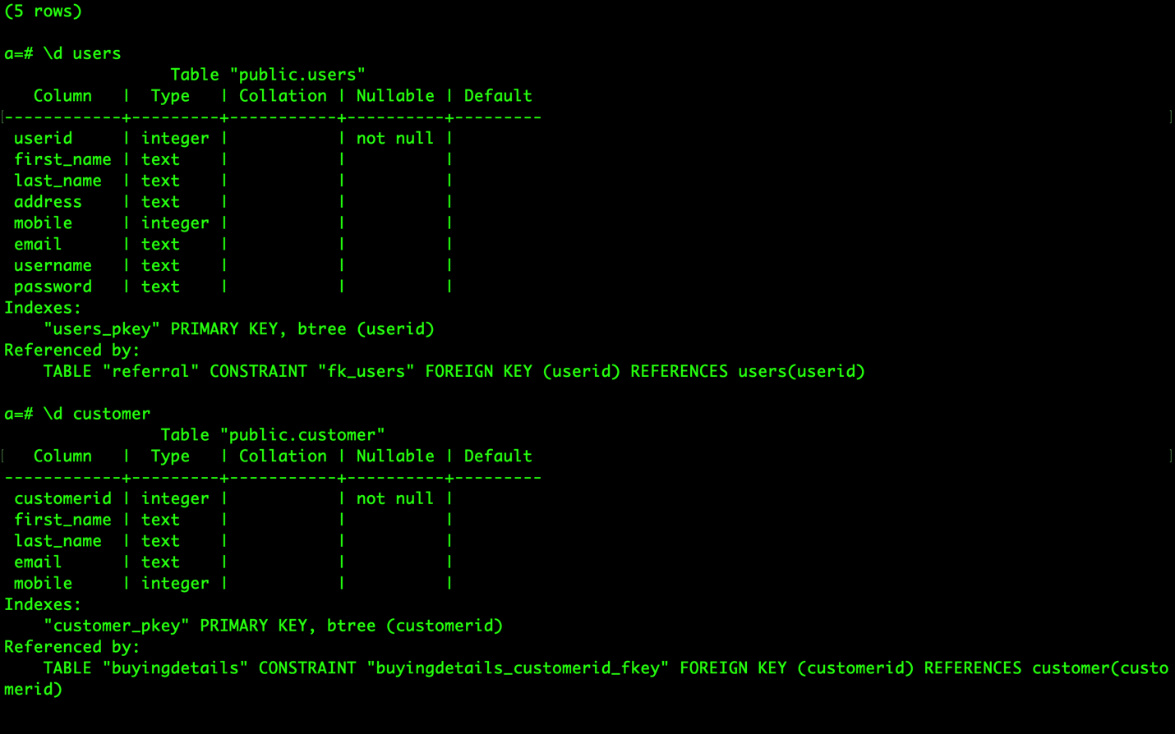

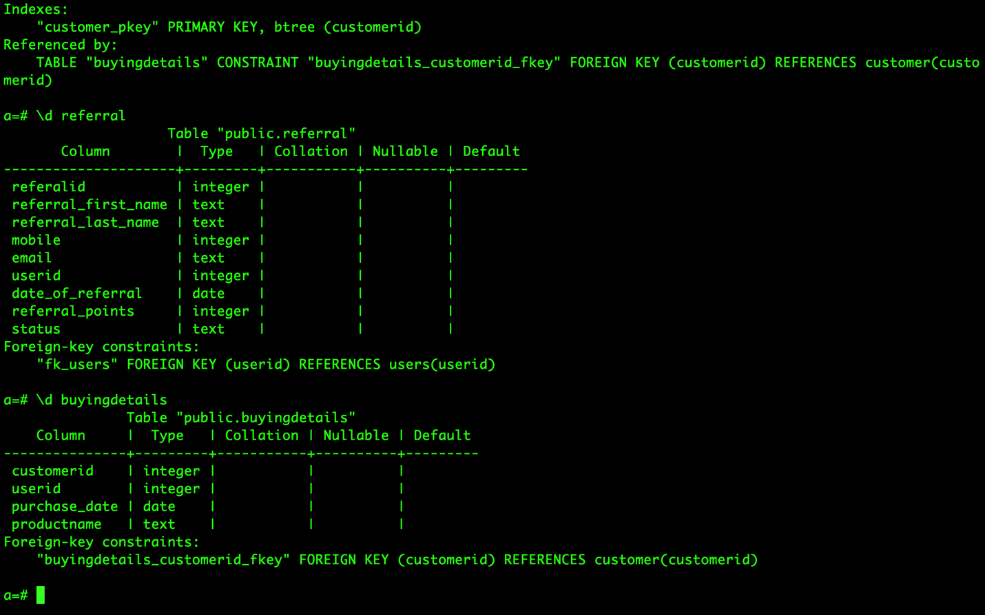

**Insert 5 records in each table and write Sqlqueries for following operations.**

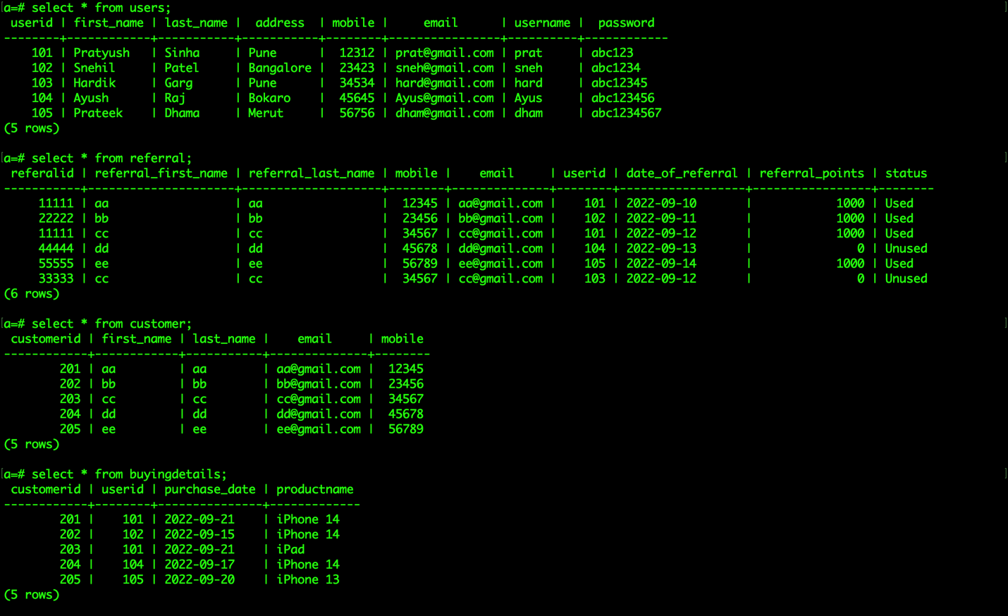

**1. Display total number of referral done by particular user by userId.**

*select userid, count(referalid) from referral group by userid;*

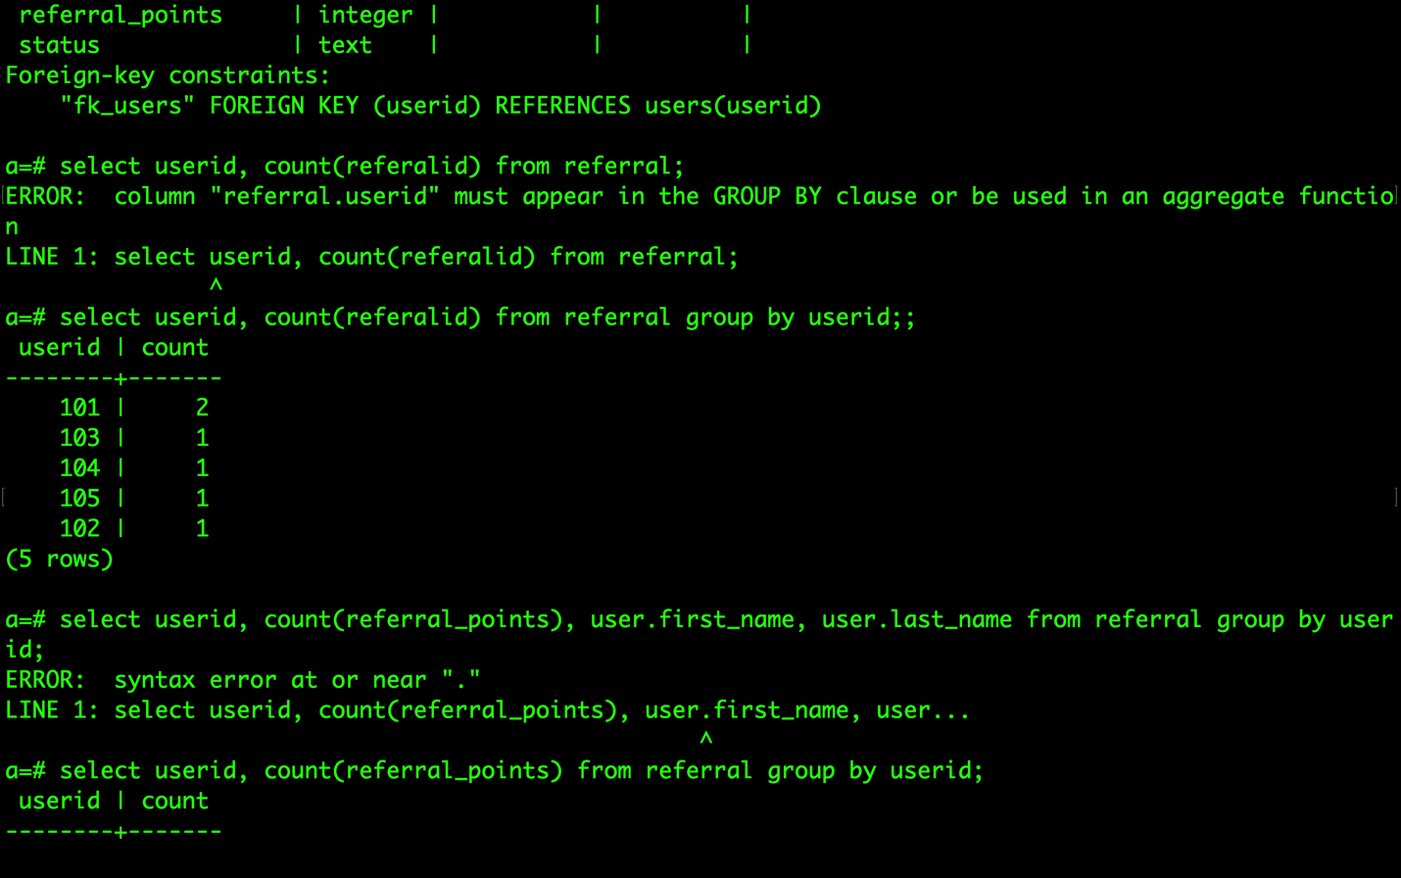

**2. Display total number of points earned by user**

*select userid, sum(referral_points) as Total_points from referral group by userid;*

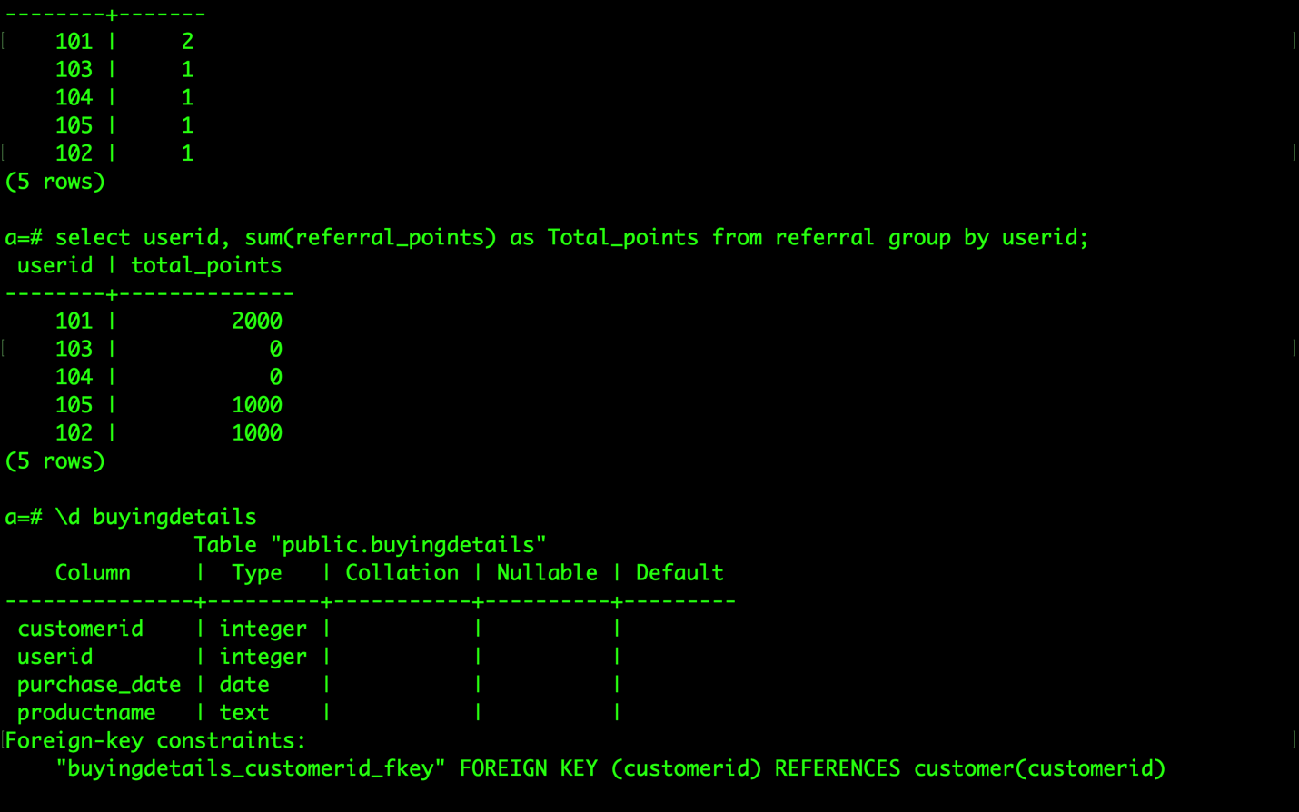

**3. Display name and mobile of user whose referral customer have purchased item on 21/09/2022**

*Select first_name, mobile from users U inner join buyingdetails B on U.userid = B.userid where purchase_date = ‘2022-09-21’;*

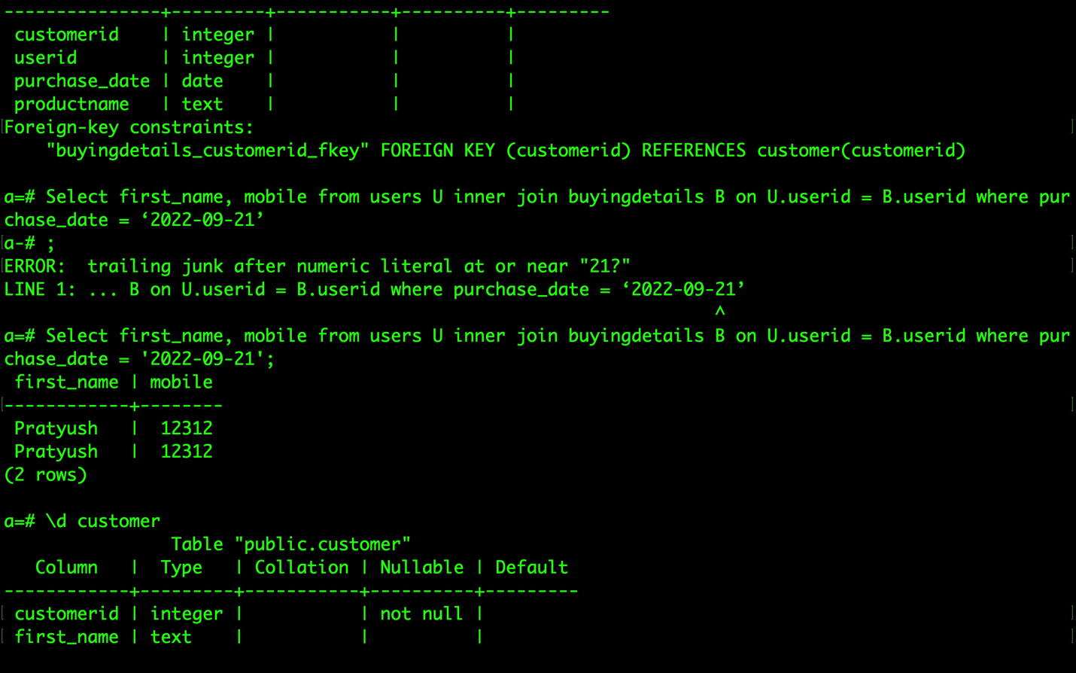

**4.Display details of customer who purchased “iPhone 14”**

*select C.customerid, first_name, last_name, email, mobile from customer C INNER JOIN buyingdetails B on C.customerid = B.customerid where productname = 'iPhone 14';*

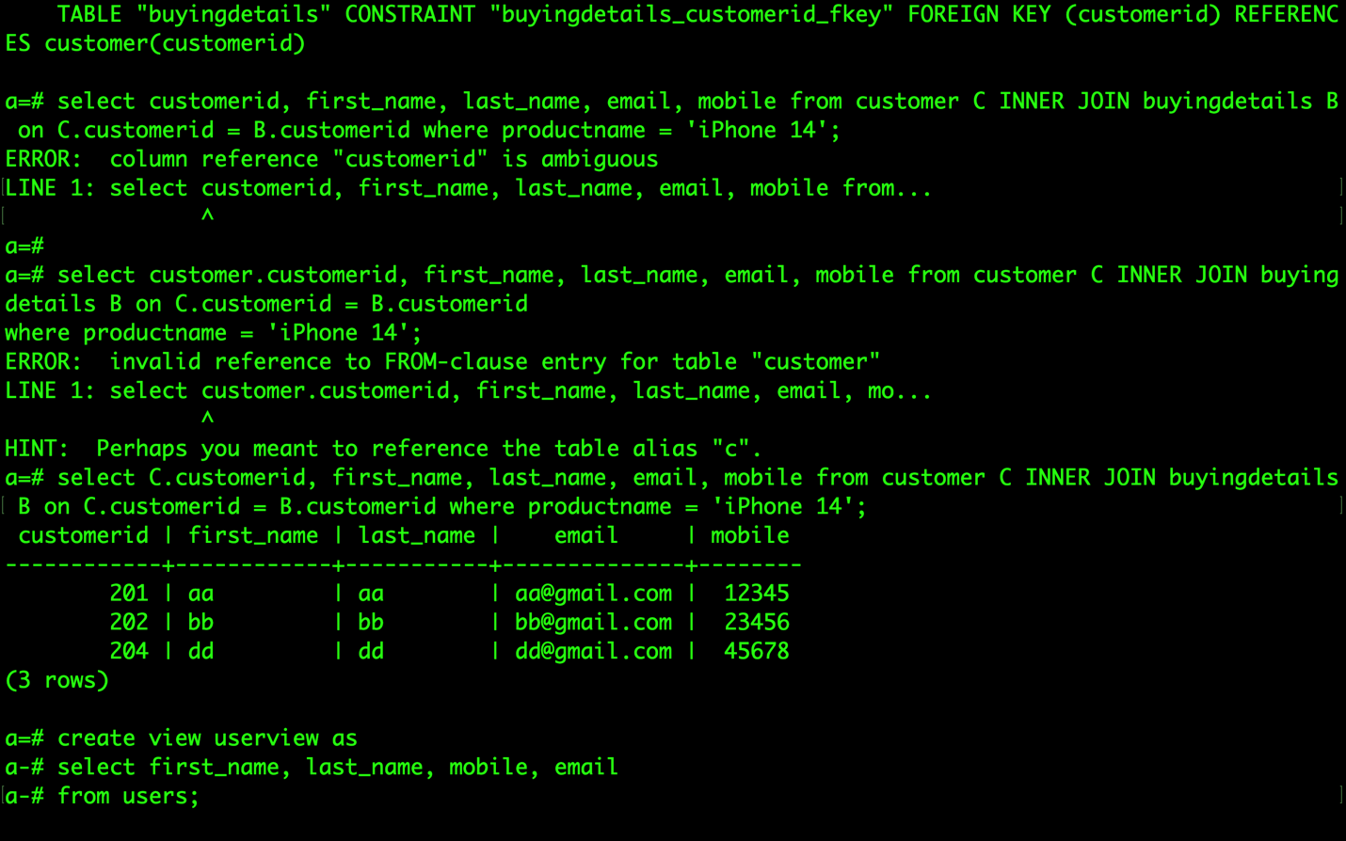

**5.delete all record of customer including purchase details Those have purchased iPhone 14.**

*delete from buyingdetails where productname = 'iPhone 14';*

*delete from customer where not exists ( select null from buyingdetails B where b.customerid = customer.customerid);*

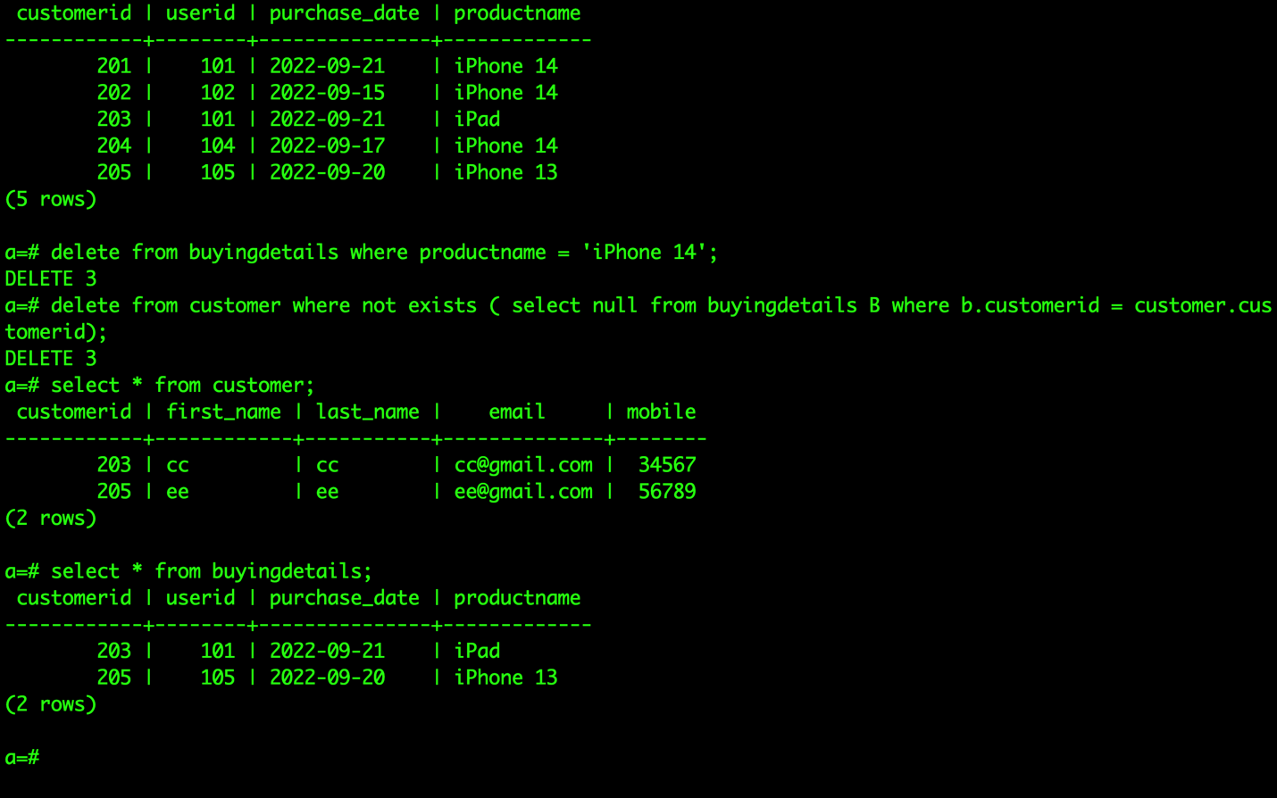

**6. Write userview to display only first name, last name, mobile and email.**

*create view userview as select first_name, last_name, mobile, email from users;*

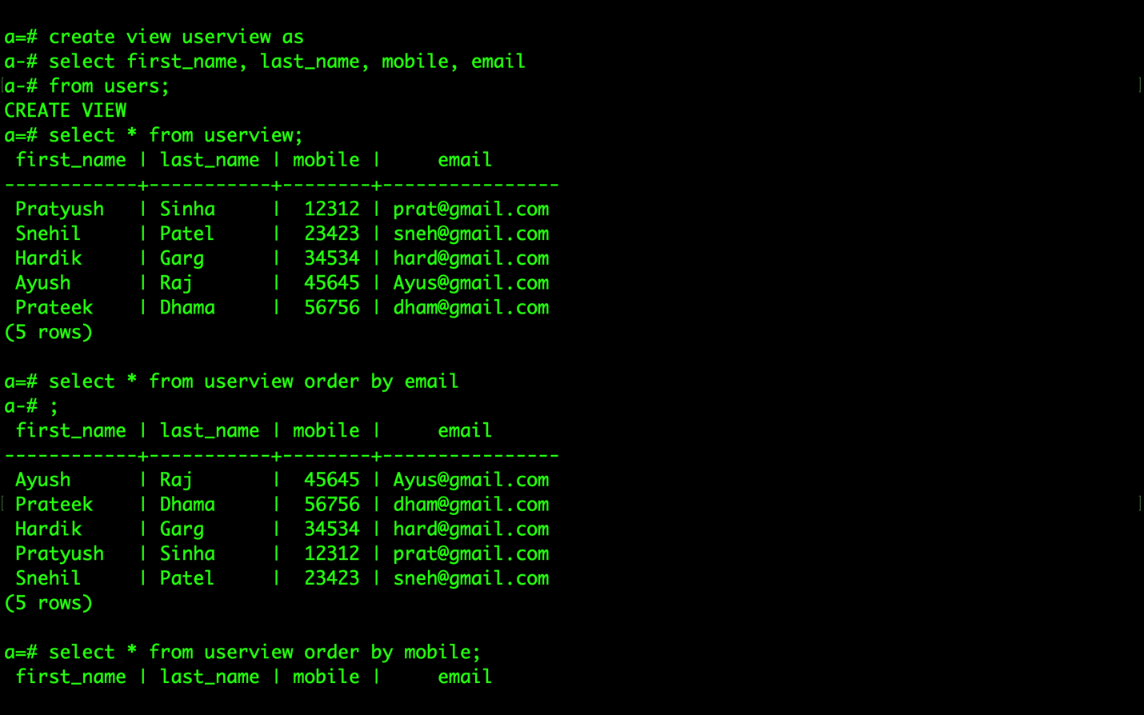

**Perform following queries on view**

**-Display record by email**

*Select * from userview order by email;*

**

**-Display record by mobile**

*Select * from userview order by mobile;*

